**Student Attendance System**

## A Major Project Report

**Submitted in Partial fulfillment for the award of Bachelor of Engineering in Computer Science & Engineering**

Submitted to

## RAJIV GANDHI PROUDYOGIKI VISHWAVIDYALAYA BHOPAL (M.P)



**MAJOR PROJECT REPORT**

Submitted by

Ankit Kumar Kasyap [0157CS161024] Akshat Gangrade[0157CS161013] Apoorva Chauhan [0157CS161035] Anushka Soni [0157CS161033]

Under the supervision of Prof.Bhawana Pillai



## Department of Computer Science & Engineering Lakshmi Narain College of Technology & Science, Bhopal (M.P.)

**Session 2019-20**

**LAKSHMI NARAIN COLLEGE OF TECHNOLOGY & SCIENCE, BHOPAL (M.P)**

## DEPARTMENT OF COMPUTER SCIENCE & ENGINEERING



**CERTIFICATE**

This is to certify that the work embodied in this Major Project work entitled **“Student Attendance System”** has been satisfactorily completed by the **Ankit Kumar Kasyap** (0157CS161024), **Akshat Gangrade** (0157CS161013) , **Apoorva Chauhan** (0157CS161035) **Anushk Soni** (0157CS161033). It is a bonafide piece of work, carried out under the guidance, Prof. Bhawana Pillai, from Department of Computer Science & Engineering, Lakshmi Narain College of **Technology & Science, Bhopal** for the partial fulfillment of the **Bachelor of Engineering** during the academic year 2019-20.

Under the Guidance of

Prof.Bhawana Pillai

Approved By

### Dr. Ashish Khare

**Prof. & Head**

**Department of Computer Science & Engineering**

Forwarded By

## Dr. A.K. Sachan Principal

**LAKSHMI NARAIN COLLEGE OF TECHNOLOGY & SCIENCE BHOPAL (M.P.)**

**DEPARTMENT OF COMPUTER SCIENCE & ENGINEERING**

**CERTIFICATE OF APPROVAL**

This foregoing project work is hereby approved as a creditable study of Engineering carried out and presented in a manner satisfactory to warranty its acceptance as a prerequisite to the degree for which it has been submitted. It is understood that by this approval the undersigned do not necessarily endorse or approve any statement made, opinion expressed or conclusion drawn their in, but approve the project only for the purpose for which it has been submitted.

# Internal Examiner External Examiner Date:

**LAKSHMI NARAIN COLLEGE OF TECHNOLOGY & SCIENCE BHOPAL (M.P.)**

## DEPARTMENT OF COMPUTER SCIENCE & ENGINEERING

### DECLARATION

We**, Ankit Kumar Kasyap** (0157CS161024), **Akshat Gangrade** (0157CS161013) , **Apoorva Chauhan** (0157CS161035) , **Anushka Soni** (0157CS161033). student of **“**Bachelor of Engineering in Computer science & engineering”, **session: 2019 - 20, Lakshmi Narain College of Technology & Science Bhopal (M.P.),** hereby declare that the work presented in this project entitled **“Student Attendance System”** is the outcome of our own work, is bonafide and correct to the best of our knowledge and this work has been carried out taking care of Engineering Ethics. The work presented does not infringe any patented work and has not been submitted to any other University or anywhere else for the award of any degree or any professional diploma.

……………………….. …………………………

**Ankit Kumar Kasyap** (0157CS161024) **Akshat Gangrade** (0157CS161013)

……………………….. …………………………

**Apoorva Chauhan** (0157CS161035) **Anushka Soni** (0157CS161033)

**Place:** Bhopal

### Date:

**LAKSHMI NARAIN COLLEGE OF TECHNOLOGY&SCIENCE, BHOPAL (M.P.)**

**DEPARTMENT OF COMPUTER SCIENCE & ENGINEERING**



**ACKNOWLEDGEMENT**

We express our deep sense of gratitude to Prof. Bhawana Pillai , department of Computer Science & Engineering, Lakshmi Narain College of Technology and Science, Bhopal, whose valuable guidance and timely help encouraged me to complete this project.

A special thanks goes to Dr. Ashish Khare, Prof.Bhawana Pillai & Head of Department, who helped me by providing timely suggestions in completing this project work. She exchanged her interesting ideas & thoughts which made this project work successful.

We would also thank our institution and all the faculty members without whom this project work would have been a distant reality.

**Ankit Kumar Kasyap** (0157CS161024) **Akshat Gangrade** (0157CS161013)

**Apoorva Chauhan** (0157CS161035) **Anushka Soni** (0157CS161033)

**INDEX**

|  |  |
| --- | --- |
| **S.No.** | **Content** |
| 1 | **Abstract** |
| 2 | **Chapter – 1**  **Introduction**   * **About** * **Motivation** * **Objectives** * **Features** |
| 3 | **Chapter – 2**  **Literature**   * **About** * **Existing System** * **Proposed System** * **Scope** * **Overall Description** |
| 4 | **Chapter – 3**  **Requirement Analysis**   * **SRS** * **S/W Requirement** * **H/W Requirement** * **Functional Requirement** * **Non - Functional Requirement** |
| 5 | **Chapter – 4**  **Design**   * **ER Diagram** * **Use Case Diagram** * **Flow Chart** * **Sequence Diagram for Admin** * **Sequence Diagram for Faculty** * **Sequence Diagram for Student** |
| 6 | **Chapter – 5**  **Implementation**   * **Introduction** * **Database Design** * **Home Page** * **Login Page** * **Add Faculty Page** * **Manage Faculty Page** * **Add Student Page** * **Manage Student Page** * **Mark Attendance Page** * **Update Student Attendance Page** * **Update Attendance Date Page** * **Update Attendance Subject Page** * **Delete Attendance Page** * **Feedback Page** * **View Feedback Page** * **Forgot Password Page** * **OTP Page** * **Reset Password Page** |
| 7 | **Chapter – 6**  **Result**   * **Faculty View Attendance Page** * **Faculty View Subject Attendance Page** * **Student View Attendance Page** * **Student View Subject Attendance Page** |
| 8 | **Chapter – 5**  **Conclusion** |
| 9 | **Chapter – 6**  **Future Work** |
| 10 | **References** |

**TABLE OF FIGURES**

|  |  |
| --- | --- |
| **Fig no.** | **Content** |
| 1 | E-R Diagram |
| 2 | Use Case Diagram |
| 3 | Flowchart Diagram |
| 4 | Sequence Diagram (For Admin) |
| 5 | Sequence Diagram (For Faculty) |
| 6 | Sequence Diagram (For Students) |
| 7 | Database Information |
| 8 | Home Page |
| 9 | Login Page |
| 10 | Add Faculty Page |
| 11 | Manage Faculty Page |
| 12 | Add Student Page |
| 13 | Manage Student Page |
| 14 | Delete All Students Page |
| 15 | Mark Attendance Page |
| 16 | Update Student Attendance Page |
| 17 | Update Attendance Date Page |
| 18 | Update Attendance Subject Page |
| 19 | Delete Attendance Page |
| 20 | Faculty View Attendance Page |
| 21 | Faculty View Subject Attendance Page |
| 22 | Student View Attendance Page |
| 23 | Student View Subject Attendance Page |
| 24 | Feedback Page |
| 25 | View Feedback Page |
| 26 | Forgot Password Page |
| 27 | OTP Page Page |
| 28 | Reset Password Page |

**ABSTRACT**

Student Attendance System is an application developed for daily student attendance in schools, colleges and institutes. It facilitates to access the attendance information of a particular student in a particular class. This system will also help in evaluating attendance eligibility criteria of a student.

In this application, the admin will be able to manage faculty, who’ll take the attendance. The attendance and students will be managed by faculty. Student will only be able to view his/her attendance on the system.

We’ve provided the email notification facility for the students in our application. The faculty will be able to send attendance related notifications to students if needed.

We’ve also provided the feedback facility in our application. Faculty and students will be able to give useful feedback for the admin. The admin can read those feedbacks and also will be able to manage them

This project mainly focuses on developing a simple and better attendance system in order to digitalise the attendance process and also conserve the nature by saving paper.

**CHAPTER - 1**

**INTRODUCTION**

* 1. **About :**

This project is developed for the convenience and ease of faculty members and students of a college or organisation where their students or their members attendance is of paramount importance.

Student Attendance System is an application developed for daily student attendance in schools, colleges and institutes. It facilitates to access the attendance information of a particular student in a particular class.

Students will be able to view his/her attendance on the system. This project mainly focuses on developing a simple and better attendance system in order to digitalize the attendance process and also conserve the nature by saving paper.

**1.2. Motivation**

The purpose of developing Student Attendance System is to computerize the tradition way of taking attendance. Another purpose for developing this software is to generate the report automatically at the end of the session or in the between of the session.

The motivation we have for this project lies in the fact that earlier so many registers were used to maintain attendance records of a student, these used to use a lot of physical space and also a lot of paperwork, to escape from this load of paperwork, we have tried to build a project that online monitors each and every students attendance record with the help of technologies that are reliable and effective.

Also due to the use of this project or software build we will be able to get a cumulative overview of attendance with the help of its graphical representation and display using web technologies.

**1.3. Objectives :**

Goal or aim of our project is to ease the process of attendance management and to introduce a better system for the same.

To provide a comparative and cumulative study of variation in each student profile of attendance for a certain duration of time.

**1.4. Features :**

1. Through the system, we can easily maintain the data without any loss or damage.

2. By using this system time consumption will be reduced.

3. By using this website students can easily know about the status of their attendance.

4. On the basis of details submitted students can match up their pace.

5. Admin monitors group activities and updation and deletion of records

6. Faculty can easily manage students and their attendance.

7. Faculty can easily notify students about their attendance if needed.

8. Faculty and Students can give useful feedback for the admin.

**CHAPTER - 2**

**LITERATURE**

**2.1. About :**

Literature of the project is associated with System analysis and it is an important part that is to be taken into consideration when we want to build a new system. In this phase, the problems in the existing system are thoroughly studied and the new system is proposed which rectifies the errors persisted in the current system. The problems are analyzed from a different point of view.

The analysis is the final stage before starting the designing of a project and hence, all the required modification should be done at this stage. Then the specification to meet the proposed system is to be produced after the analysis stage that the project persons will use it for further. System Analysis then is the process of gathering and interpreting facts, diagnosing problems and using the information to recommend improvements to the system. Before the development of any project can be pursued, a systematic study is conducted to learn the details of the current business situation. Information gathered through the study, forms the basis for creating alternative design strategies. Management selects the strategy to pursue. System Analysis is about understanding situations. The effective analysis includes investigation and questioning to learn how a system operates and to identify the requirements for a new or modified one. For the development of any good project, proper analysis of the existing system is a prerequisite. Therefore, a detailed analysis of the existing system should be conducted. For this purpose, the system should be broken down into various subsystems and these subsystems were analyzed closely to identify the problem areas.

**2.2. Existing System :**

At present most of the organisation use the traditional and obsolete techniques that include the management of many papers and register to keep the attendance of all students updated.

Also if data is maintained in a physical substance here files and registers, over time they can be lost or misplaced where on the other hand the computerized data is intact.

If a mistake is done on paper it is difficult and also laborious to erase it and rewrite it, here the system provides us with the flexibility to do changes and updation.

It requires the maintenance of paper and pen, a system will in any case just require an electronic device.

**Limitations :**

1.Time delay

2.Redundancy

3.Accuracy

4.Information Retrieval

5.Same Storage Media

**2.3. Proposed System :**

The proposed portal is developed using MySQL as back end and HTML, CSS, JSP , JAVSCRIPT as front end for the organization that wants to digitize their existing systems for better security and safety.

In brief, the proposed system will be as follows :

* All faculty members will be added and managed by admin.
* All students will be added and managed by faculty.
* The faculty will have an id and password to update attendance
* A student can log in and check his/her attendance.
* The details about the attendance will be shown to all students.
* Subject wise as well as overall display of attendance.
* Attendance notification to students by faculty.

**2.4. Scope :**

The scope of the project is that it can be used by a Student , if he is added by faculty, who are added by admin.

Anyone having internet connection can access their attendance records if they are valid users.

**2.5. Overall Description :**

In our application, we have three modules

1. Masters/Admin

2. Faculty

3. Students

**1. Masters/Admin :** All faculty and institution information are maintained and functioned by the admin. Admin can access and modify the data as per the needs and mistakes.

They can also view the feedbacks from faculty & students, and take counter actions.

**2. Faculty :** These are the authorities which are added by an admin, they will manage students and their data . Faculty will put online each students attendance.They can put feedbacks too.

**3. Student :** students have their updated attendance maintained with a comparative analysis of their subject wise attendance. They can provide feedback, this feedback if are for faculty will be forwarded to them.

**Attendance :** This page stores the information about attendance of all subjects. By this page the faculty can directly add the attendance, edit the attendance.

**Notification :** This module allows faculty to send attendance notifications to students if needed.

**Feedback :** By this module students and faculty can send their feedback to admin and view the reply which is sent.

**CHAPTER - 3**

**REQUIREMENT ANALYSIS**

**3.1. System Requirement Specification :**

System requirement give an idea about what are the necessary things that are needed for the proposed system, which plays a very important role in the development of any system. This chapter deals with what are hardware components that are needed for the system, application, software that is required for the development of the system and the functional requirement of the system. Frontend tools helps to visualize the system, while backend helps in activities which are not visible to the end user.

**Modules :**

This project consists of 3 modules

1. Masters/Admin

2. Faculty

3. Student

**Functionalities :**

**Admin module :**

1. Manages faculty details.

2. Manages faculty data.

3. View feedback and manage them.

**Faculty module :**

1. Manages student details.

2. Manages Attendance details.

3. Sends feedback to admin.

4. Sends attendance notification to students.

**Student module :**

1.View attendance.

2. Sends feedback to admin.

**3.2. Software Requirements :**

OPERATING SYSTEM : Windows/Linux/MacOs

ENVIRONMENT : Eclipse IDE

PROGRAMMING LANGUAGE : Java

WEB TECHNOLOGY : HTML , CSS , JAVASCRIPT

BACKEND : MySQL SERVER 2008

**3.3. Hardware Requirements:**

PROCESSOR : Intel Pentium 4 or more

RAM : 1 GB or more

HARD DISK : 40 GB hard disk recommended for Primary Partition

KEYBOARD : STANDARD 102 KEYS

MOUSE : 3 BUTTONS

MONITOR : 15” COLOR

**3.4. Functional Requirements :**

**3.4.1. Input/output :**

Admin is required to log into the application using his id and password and then he/she is allowed to manage faculty. A faculty in turn is responsible for the management of students and their attendance. A student can simply view the attendance. The admin is also allowed to manage feedback.

**3.4.2. Storage Requirements :**

All the details of Attendance, students are stored in the database and the data can be updated through the database.

**3.5. Non Functional Requirements :**

**Usability :**

The system is designed with a completely automated process. Hence there is no or less

intervention.

**Reliability and Security :**

The system is more reliable because of the qualities that are inherited from the chosen platform java. And it provides secure access of confidential data with unique id and password.

**Supportability :**

The system is designed to be the cross-platform supportable.The system is supported on a wide range of hardware and software platform.

**CHAPTER - 4**

**DESIGN**

**4.1. Introduction :**

Systems design is the process Of defining the architecture, components, modules, interfaces, and data for a system to satisfy specified requirements. One could see it as the application of systems theory to product development. There is some overlap and synergy with the disciplines of systems analysis, systems architecture and systems engineering.

**4.2. ER DIAGRAM**

An entity–relationship model (ER model for short) describes interrelated things of interest in a specific domain of knowledge. A basic ER model is composed of entity types (which classify the things of interest) and specifies relationships that can exist between entities (instances of those entity types). In software engineering, an ER model is commonly formed to represent things a business needs to remember in order to perform business processes. Consequently, the ER model becomes an abstract data model, that defines a data or information structure which can be implemented in a database, typically a relational database.

Entities are represented by means of rectangles. Rectangles are named with the entity set they represent.

Attributes are the properties of entities. Attributes are represented by means of ellipses. Every ellipse represents one attribute and is directly connected to its entity (rectangle).

If the attributes are composite, they are further divided in a tree like structure. Every node is then connected to its attribute. That is, composite attributes are represented by ellipses that are connected with an ellipse. Multivalued attributes are depicted by double ellipse. Derived attributes are depicted by dashed ellipse.

Relationships are represented by diamond-shaped box. Name of the relationship is written inside the diamond-box. All the entities (rectangles) participating in a relationship, are connected to it by a line.

Here, there are four different entities : Admin, Student, Faculty, and Feedback. The attributes and relationship among these entities is shown below in the figure.

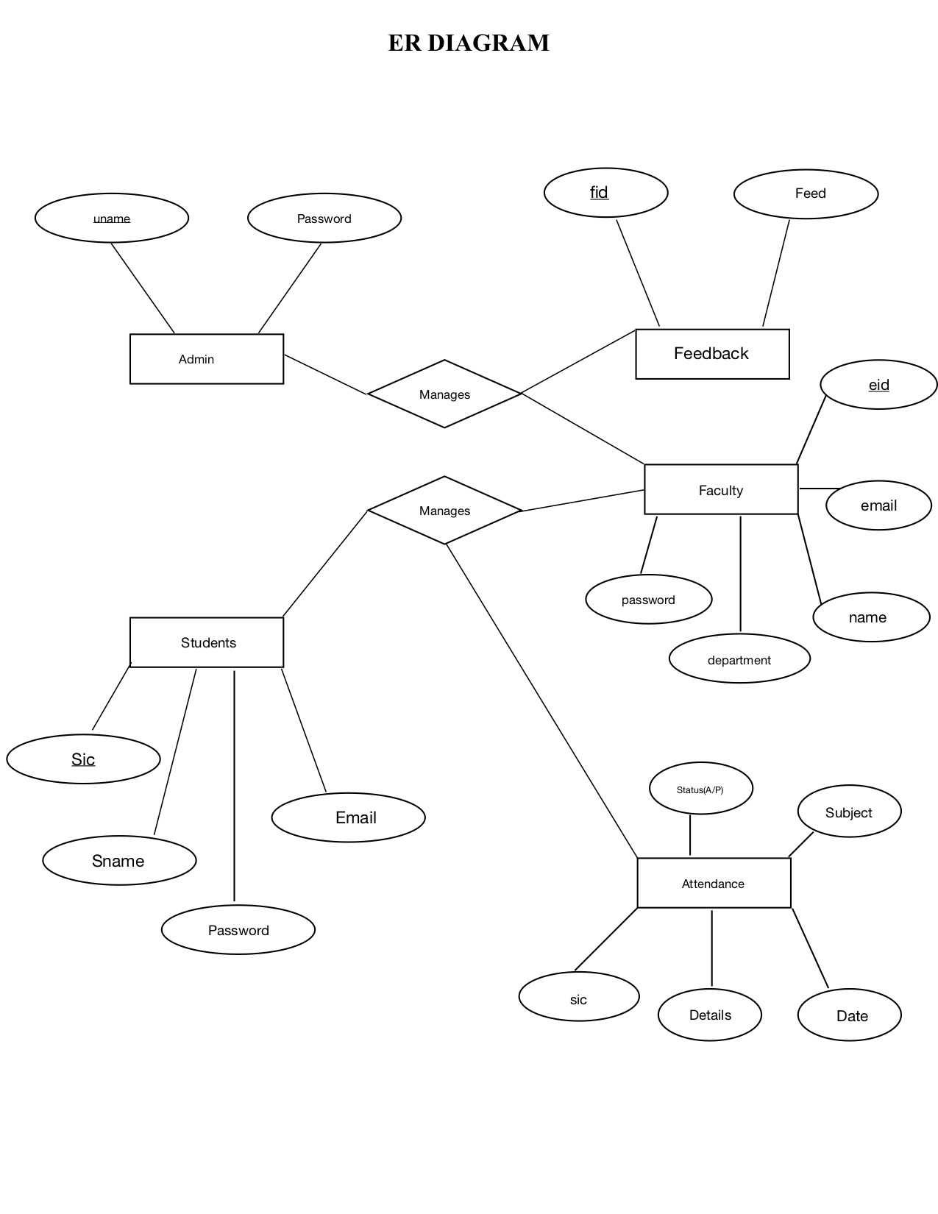

**4.3. USE CASE DIAGRAM**

Use case diagram is a dynamic or behavior diagram in UML. Use case diagrams model the functionality of a system using actors and use cases. Use cases are a set of actions, services, and functions that the system needs to perform.

Here there are three actors : Admin, Faculty and Students. .

**Use case diagram for Attendance System :**

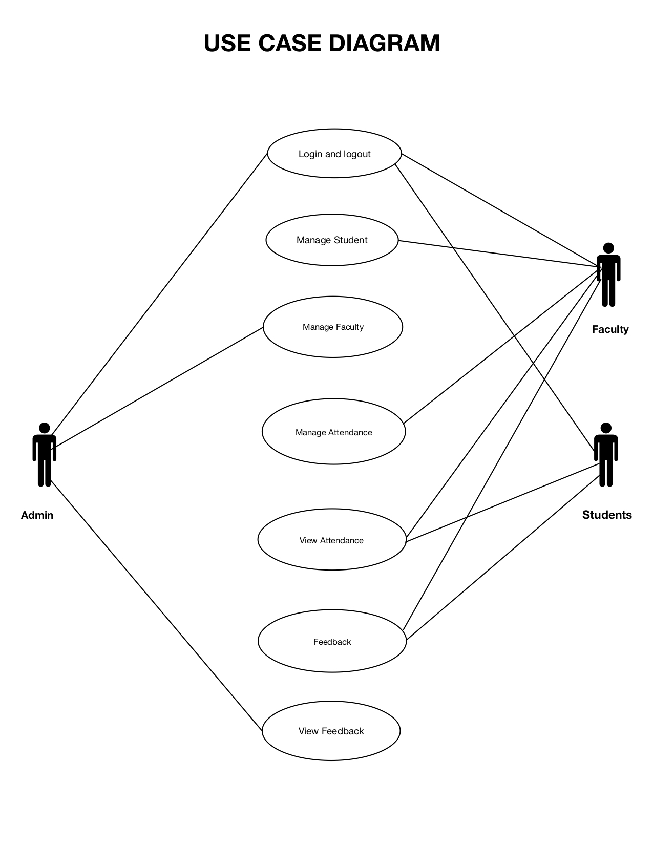

**4.4. FLOWCHART DIAGRAM**

A flowchart is a diagram that depicts a process, system or computer algorithm. They are widely used in multiple fields to document, study, plan, improve and communicate often complex processes in clear, easy-to-understand diagrams. Flowcharts, sometimes spelled as flow charts, use rectangles, ovals, diamonds and potentially numerous other shapes to define the type of step, along with connecting arrows to define flow and sequence. 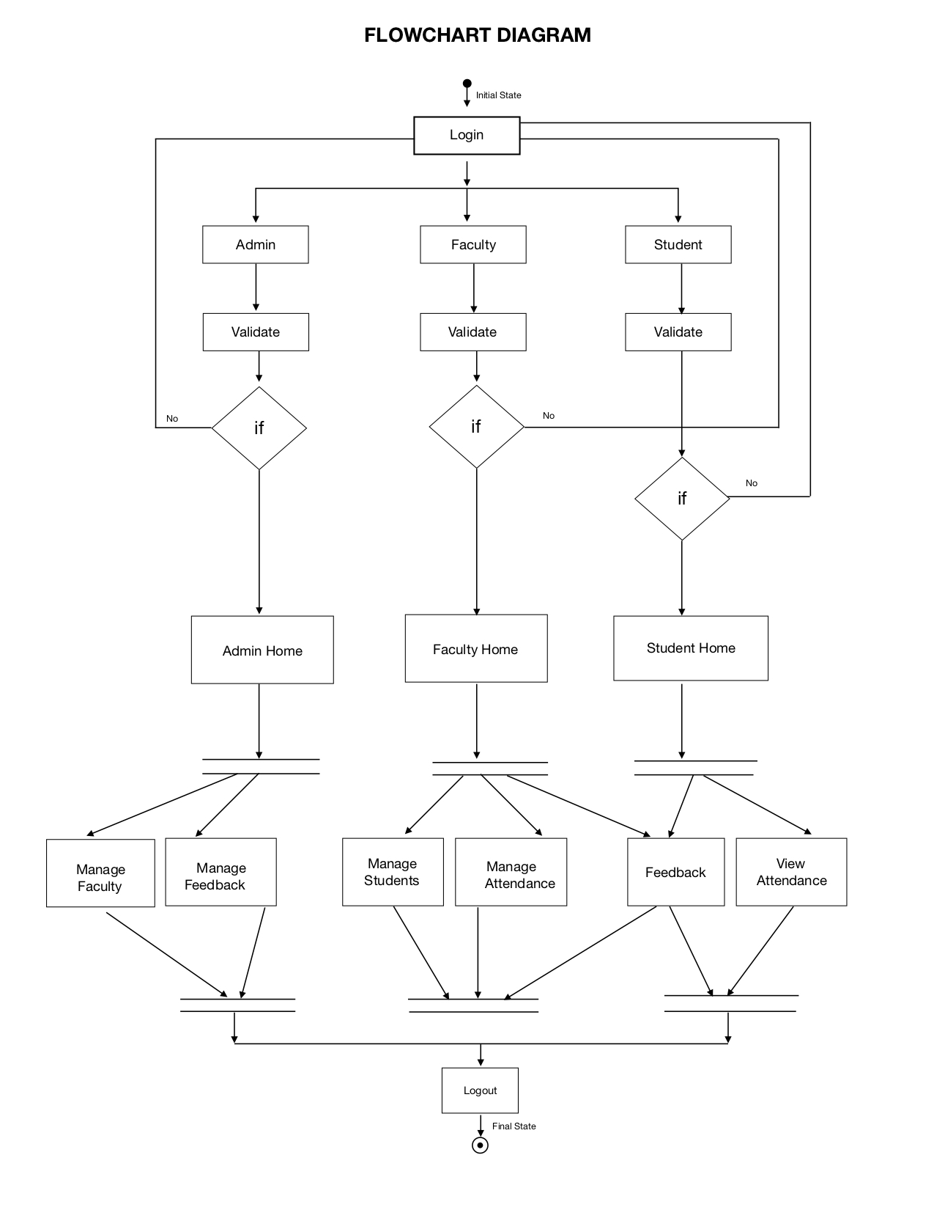

**4.5. SEQUENCE DIAGRAM**

A sequence diagram describes an interaction among a set of objects participated in a collaboration (or scenario), arranged in a chronological order; it shows the objects participating in the interaction by their "lifelines" and the messages that they send to each other.

This documentation contains two sequence diagrams one as per the admin's perspective and another for the user's perspective.

**Lifeline :**

A lifeline represents an individual participant in the Interaction.

**Actor :**

An Actor a type of role played by an entity that interacts with the subject.

**Activation :**

An activation is represented by a thin rectangle on a lifeline) represents the period during which an element is performing an operation.

**4.5.1. Sequence Diagram For Admin :**

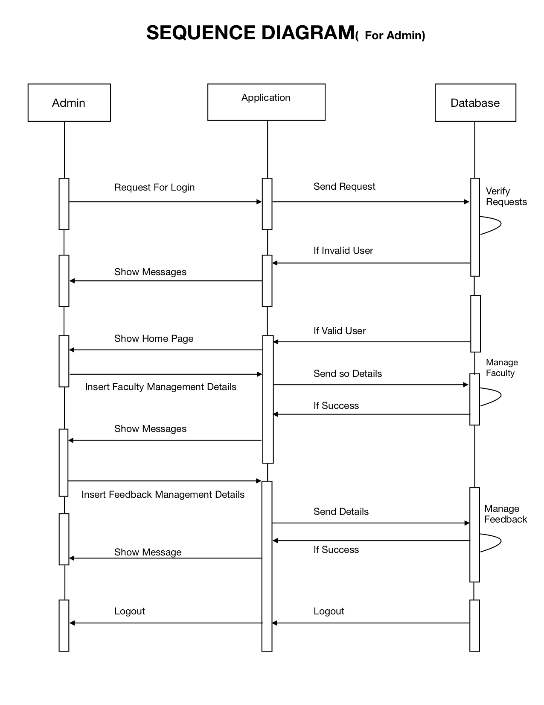

**4.5.2. Sequence Diagram For Faculty :**

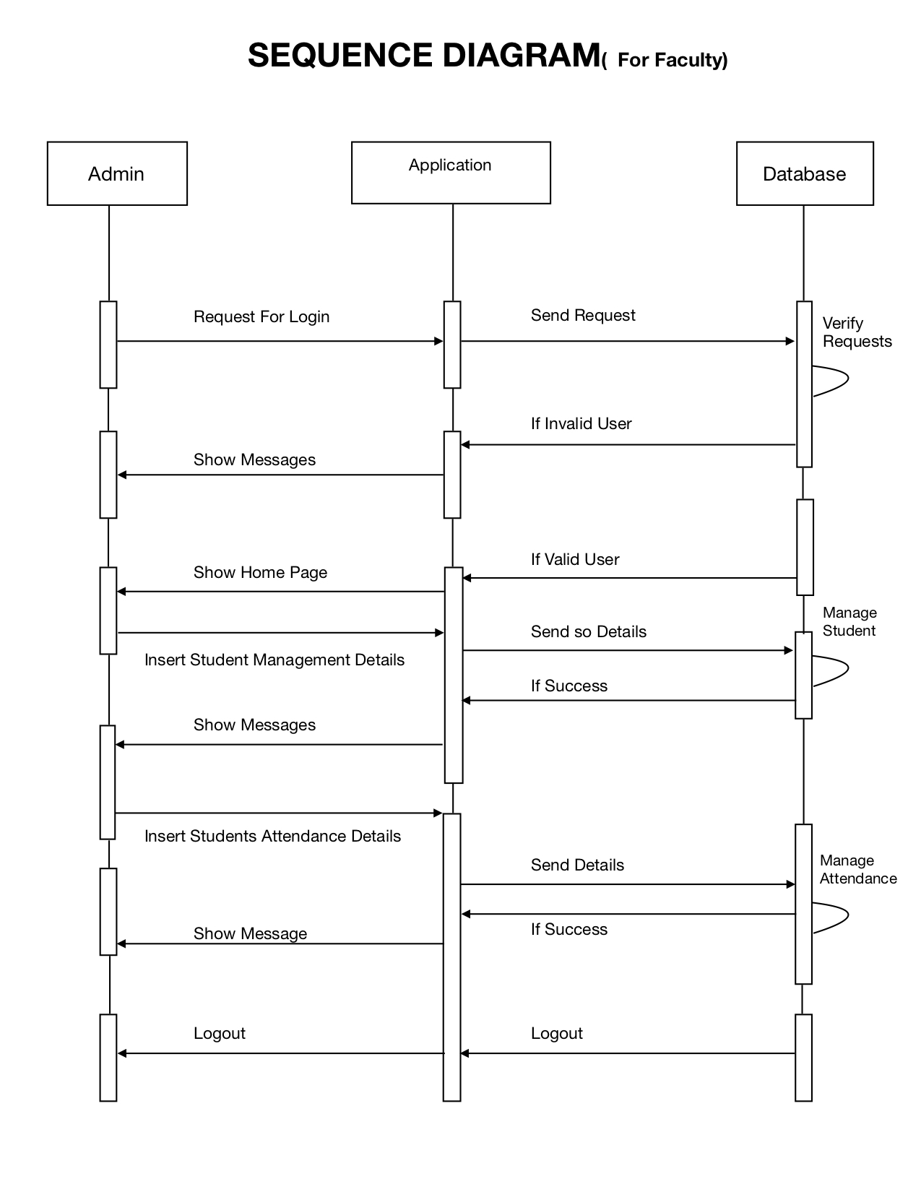**4.5.1. Sequence Diagram For Student :**

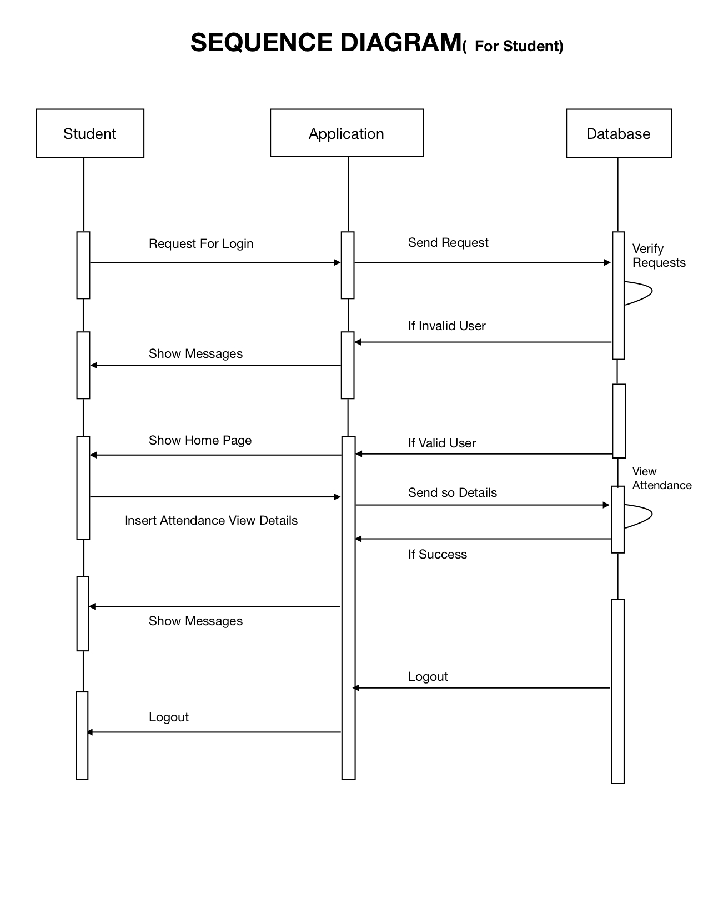

**CHAPTER - 5**

**IMPLEMENTATION**

**5.1. Introduction :**

To provide flexibility to the users, the interfaces have been developed that are accessible through a browser. The GUI’S at the top level have been categorized as :

1. Administrative user interface

2. The operational or generic user interface

The ‘administrative user interface’ concentrates on the consistent information that is practically, part of the organizational activities and which needs proper authentication for the data collection. These interfaces help the administrators with all the transactional states like Data insertion, Data deletion and Data updation along with the extensive data search capabilities.

The ‘operational or generic user interface’ helps the end users of the system in transactions through the existing data and required services. The operational user interface also helps the ordinary users in managing their own information in a customized manner as per the included flexibilities.

**5.2. Database Information**

A single database can house hundreds of tables, each playing its own unique role in the database schema. SQL tables are comprised of table rows and columns. Table columns are responsible for storing many different types of data, including numbers, texts, dates, and even files.

The Project mainly contains of five tables in which it holds up certain columns along with their respective datatypes which are in the picture below.

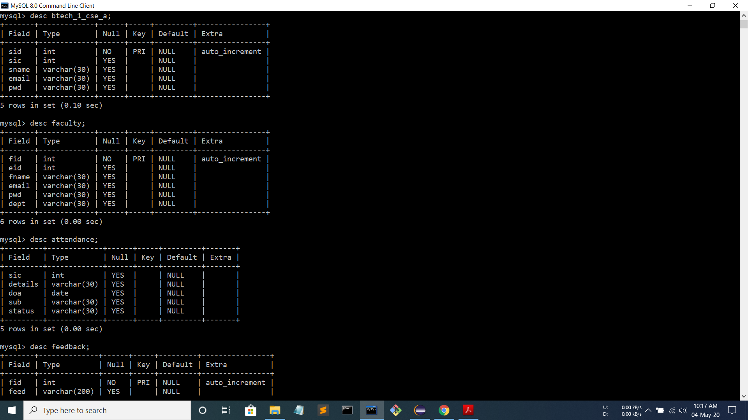

**5.3. Home Page**

This page open on application startup. Below is the home page which is displayed when the application is executed.

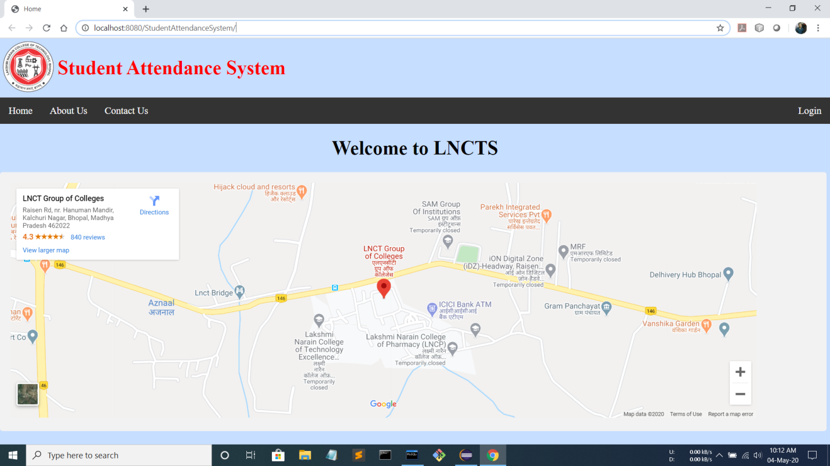

**5.4. Login Page**

This is the login page using which, admin, faculty, and student can be logged in into the system.

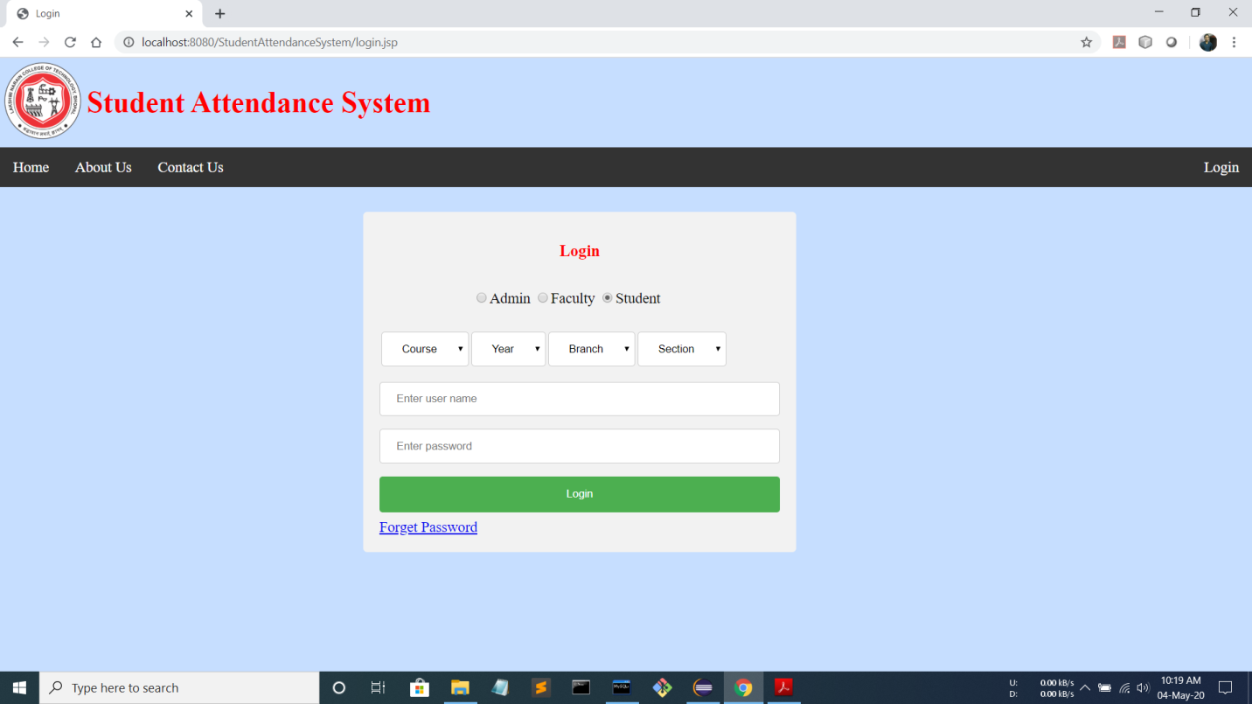

**5.5. Add Faculty Page**

This page is present in the admin menu. This page facilitates the admin to add new faculty members to the system.

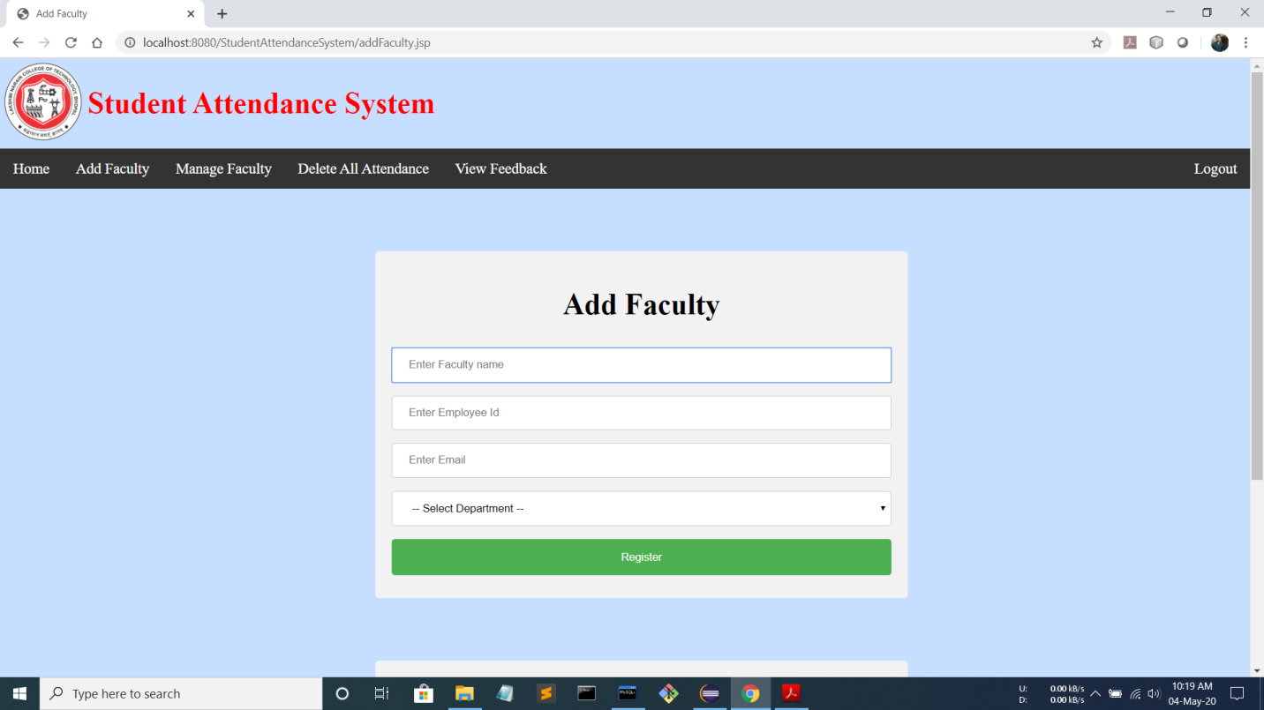

**5.6. Manage Faculty Page**

This page is present in the admin menu. This page facilitates the admin to manage(add, update, and delete) the faculty members in the system.

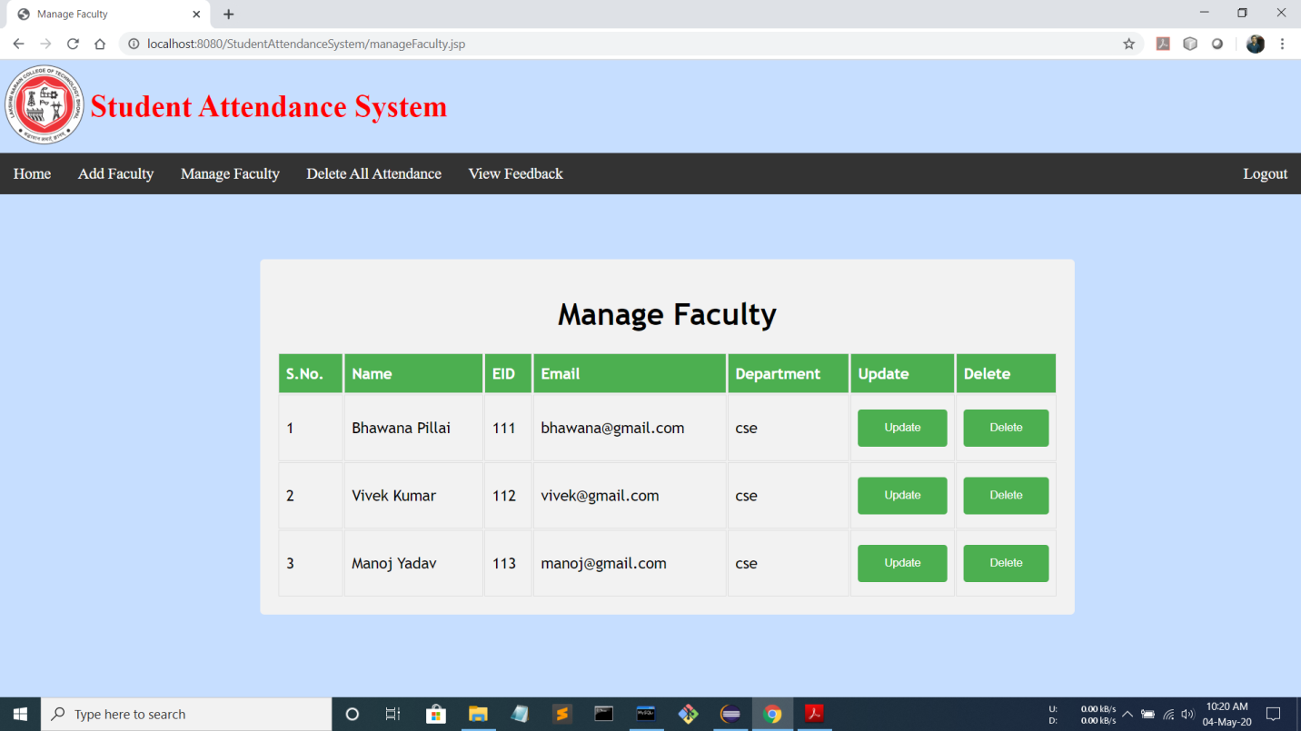

**5.7. Add Student Page**

This page is present in the faculty menu. This page facilitates the faculty to add new students to the system.

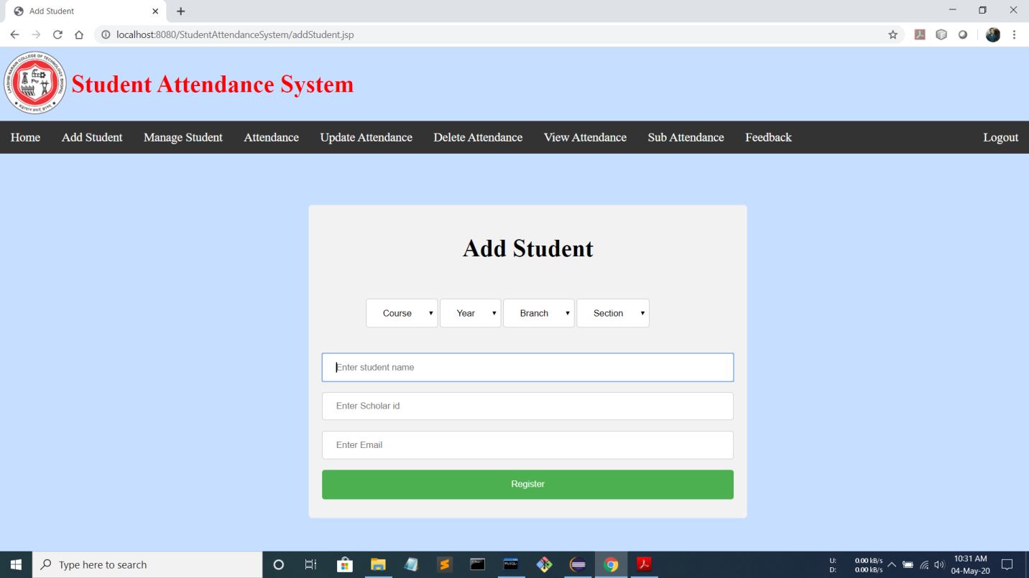

**5.8. Manage Student Page**

This page is present in the faculty menu. This page facilitates the faculty to manage(add, update, and delete) the students in the system.

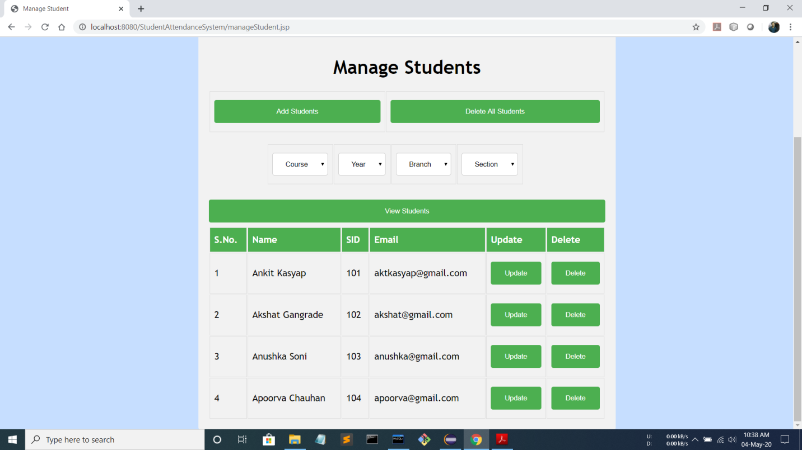

**5.9. Mark Attendance Page**

This page is present in the faculty menu. This page facilitates the faculty to mark student’s attendance of particular date and subject in the system.

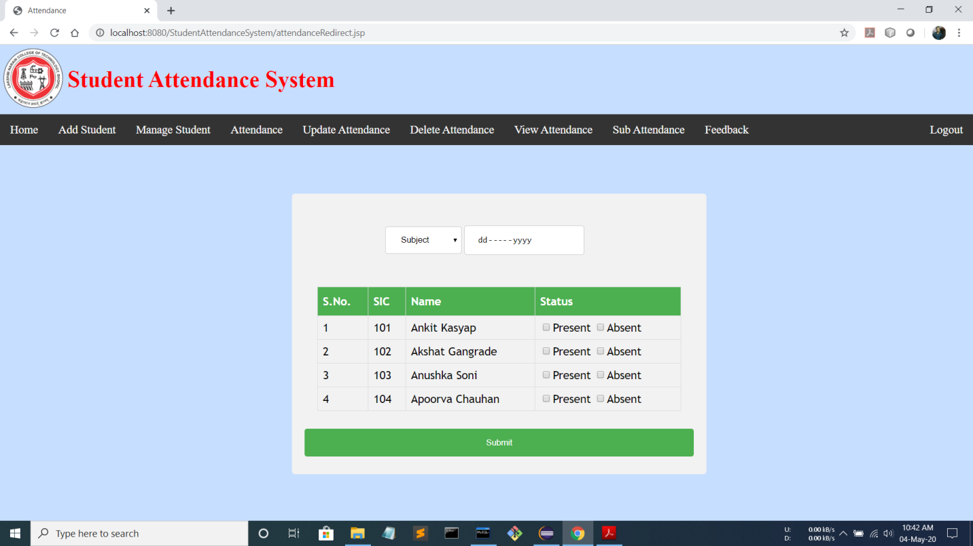

**5.10. Update Student Attendance Page**

This page is present in the faculty menu. This page facilitates the faculty to change status(absent/present) of a particular student of particular date and subject in the system.

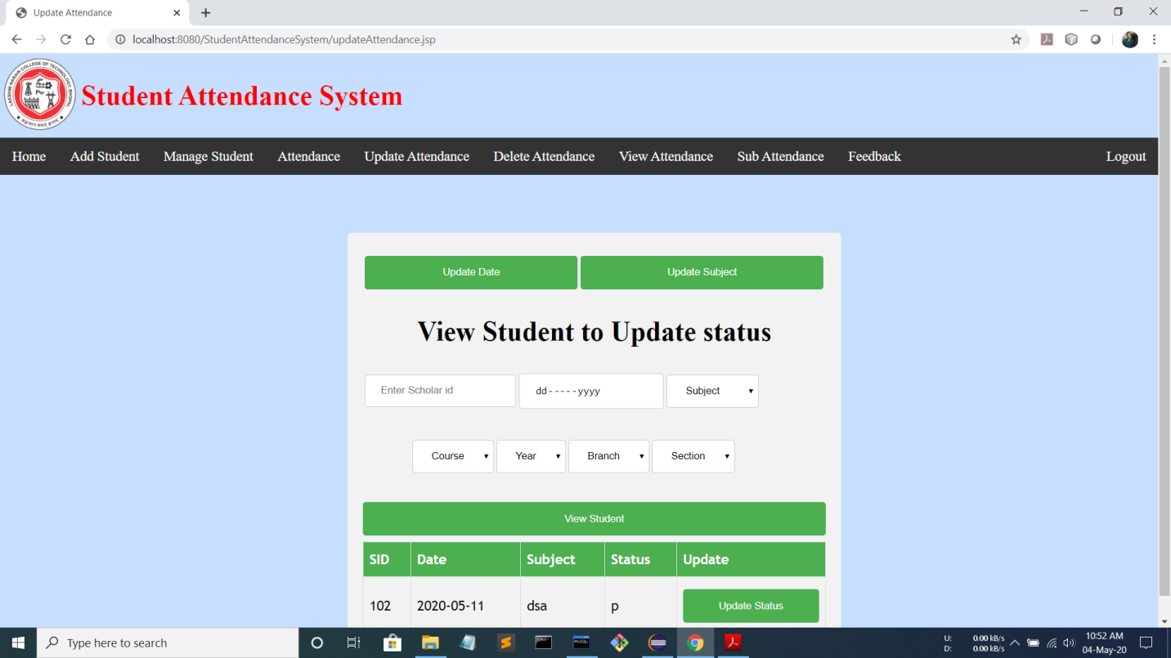

**5.10. Update Student Attendance Page**

This page is present in the faculty menu. This page facilitates the faculty to change status(absent/present) of a particular student of particular date and subject in the system.

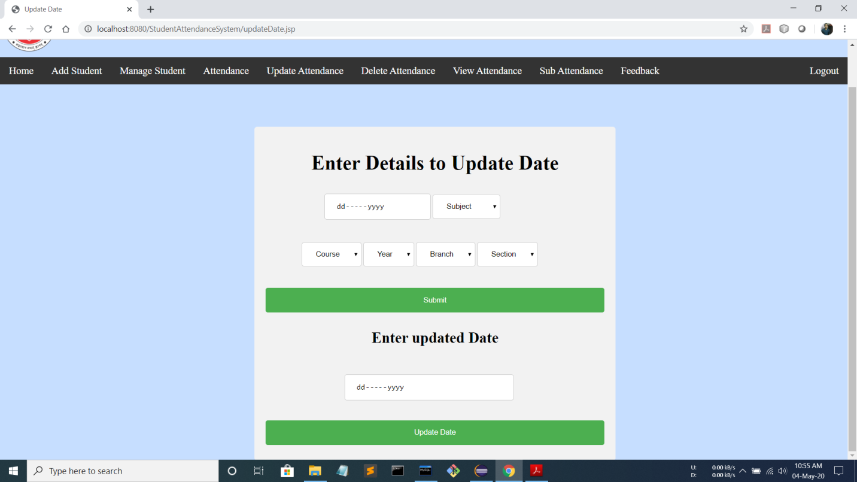

**5.12. Update Attendance Subject Page**

This page is present in the faculty menu. This page facilitates the faculty to change subject of a particular date and subject in the system.

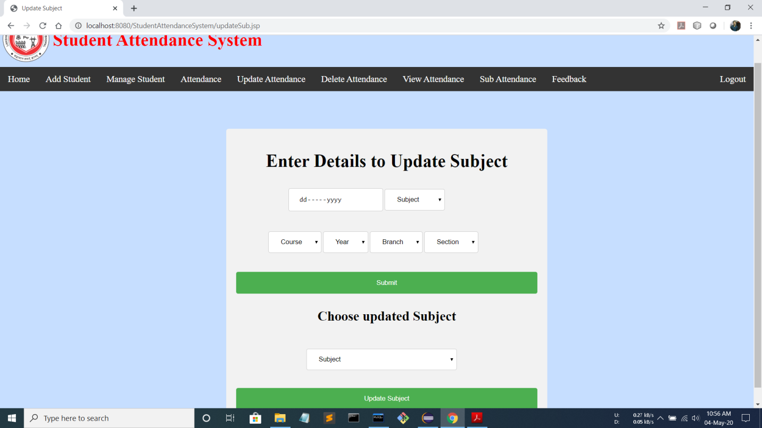

**5.13. Delete Attendance Page**

This page is present in the faculty menu. This page facilitates the faculty to delete attendance of a particular date and subject in the system.

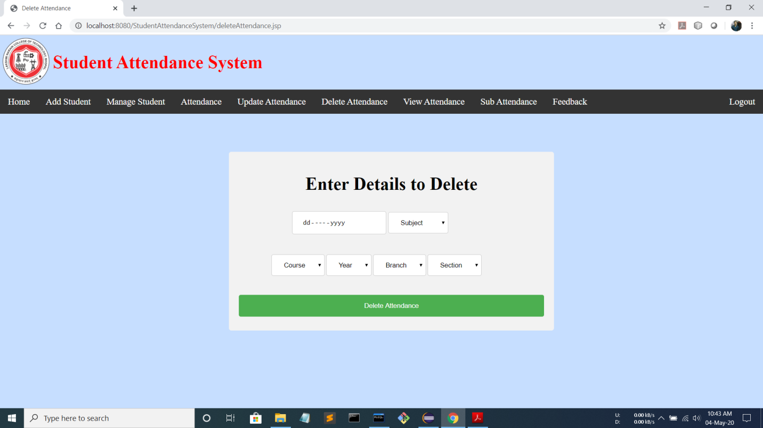

**5.14. Feedback Page**

This page is present in the faculty and student menu. This page facilitates the faculty and student to give their feedback and suggestions to the admin in the system.

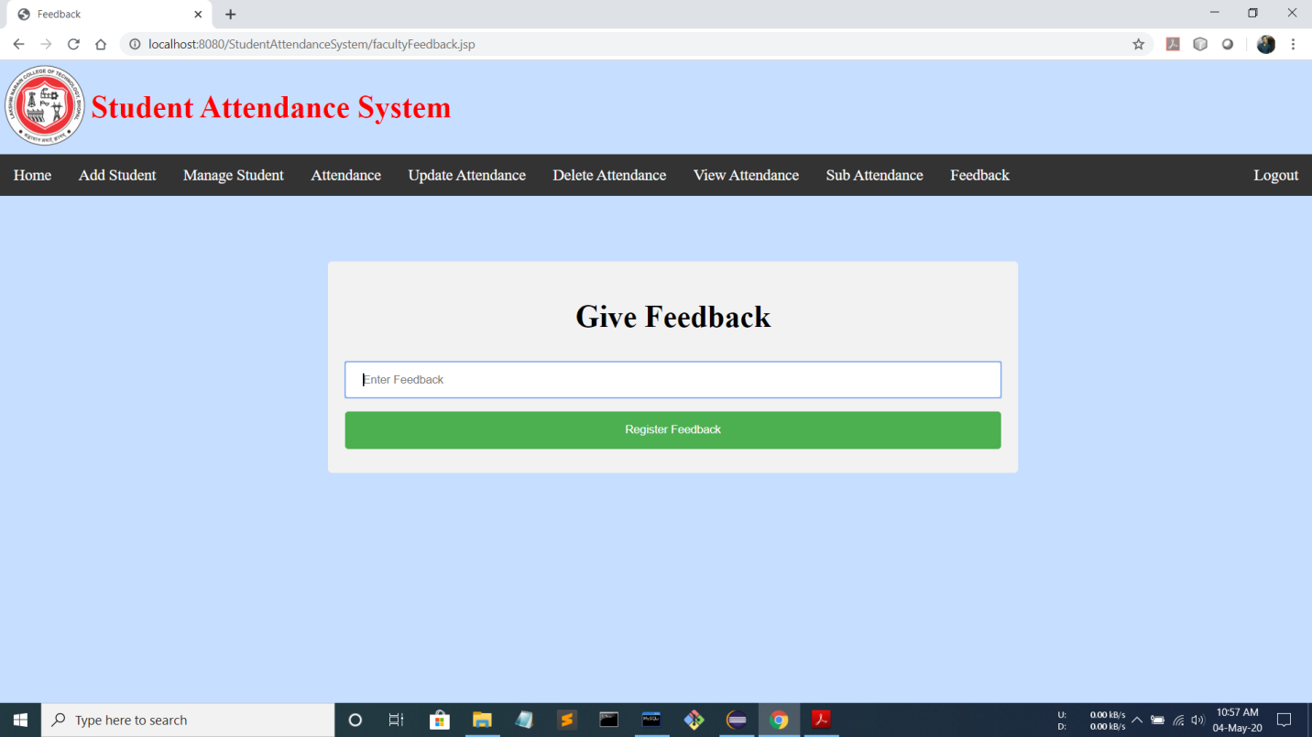

**5.15. View Feedback Page**

This page is present in the admin menu. This page facilitates the admin to view the feedback given by students and faculty and manage them in the system.

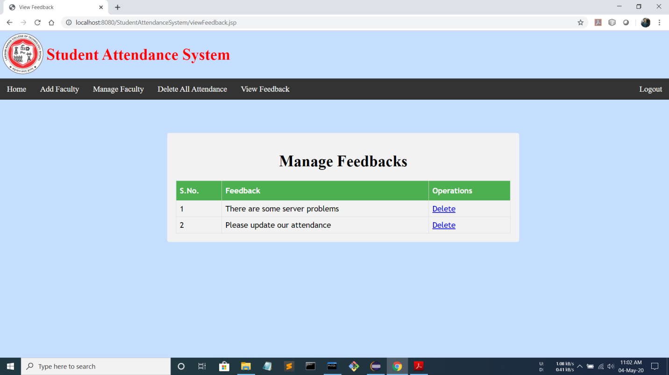

**5.16. Forgot Password Page**

This page enables a student/faculty to recover his forgotten password. He/she has to provide his/her username on which a One Time Password (OTP) is sent for password recovery.

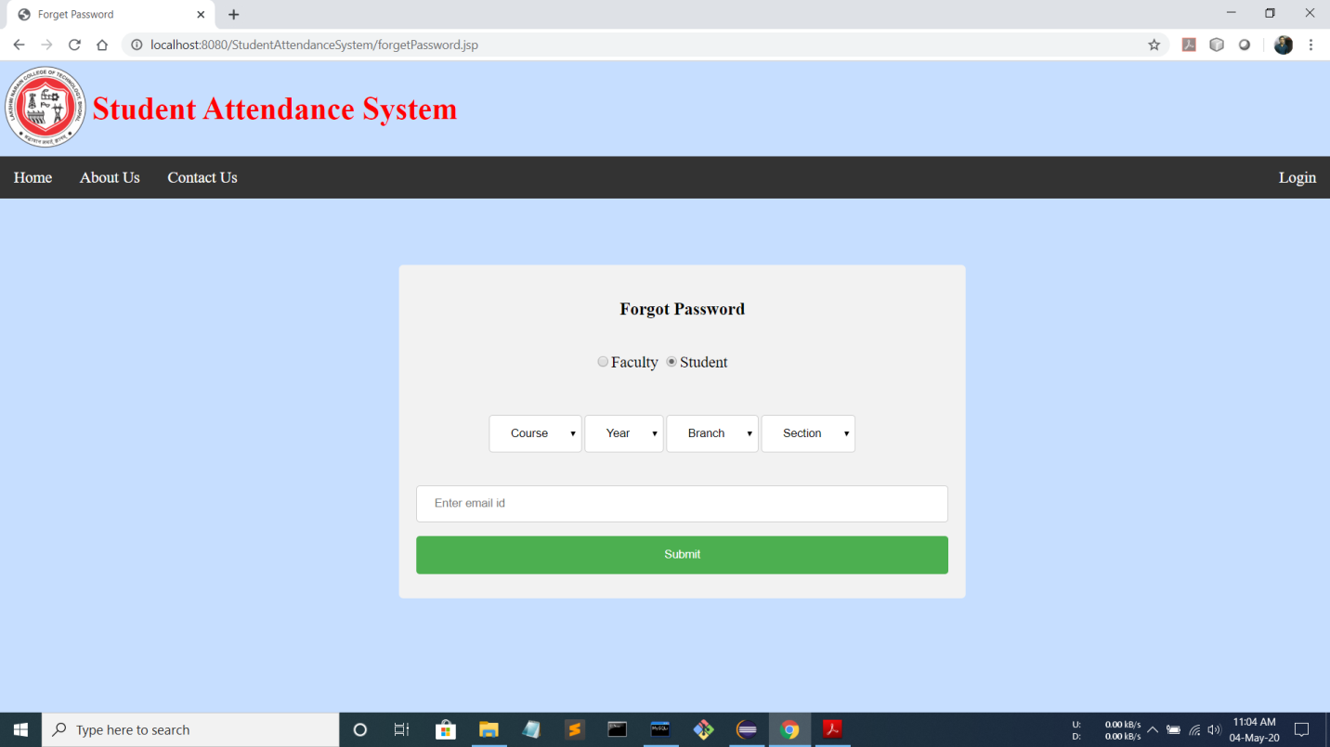

**5.17. OTP Page**

This page enables the user to enter the OTP sent to their respective email-id to recover their password. Once they enter a valid OTP sent to the respective email-id, the user is able to reset his new password.

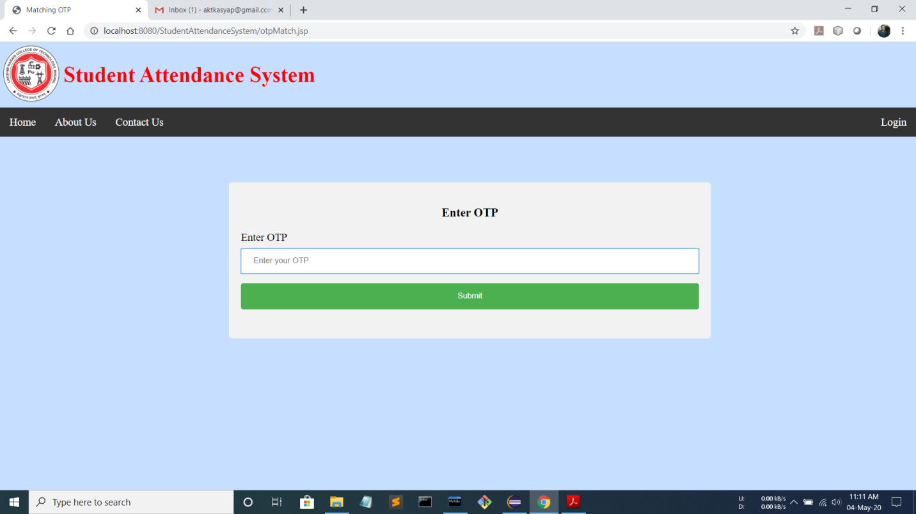

**5.18. Reset Password Page**

Once the user has entered the valid one time password(OTP) sent to his email-id, he is able to reset his password. The entered password will be directly updated in the database and it will be his/her new login password.

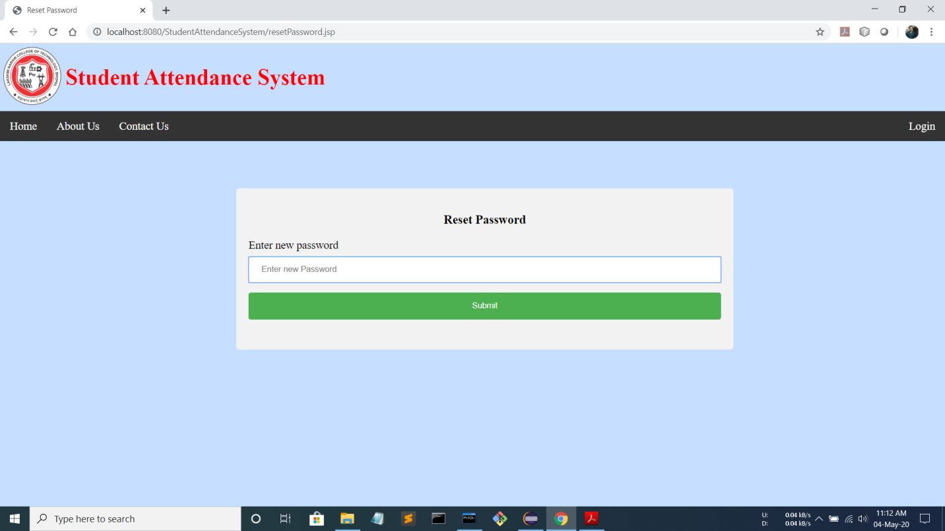

**CHAPTER - 6**

**RESULT**

Attendance System is a one-stop solution through which various services for various students and faculty can be solved, as paper based system is highly time consuming to use and get the information.

Here in this application student can easily login with email and password to view their overall as well as subjective attendance.

Apart from attendance, it also has some salient features like sending attendance notification to students through email by the faculty, and providing some suggestions to the admin by giving feedbacks.

Both Student and Faculty can get the attendance update from this application.

Moreover, this application is easy to use & simple, and the execution time is also kept very negligible for fast access of the system.

Here are some screenshot which actually shows the working and how the result is going to display on the screen.

**6.1. Faculty View Attendance Page**

This page is present in the faculty menu. This page facilitates the faculty to view the overall attendance of the students of a particular class and to send attendance notifications to the students in the system.

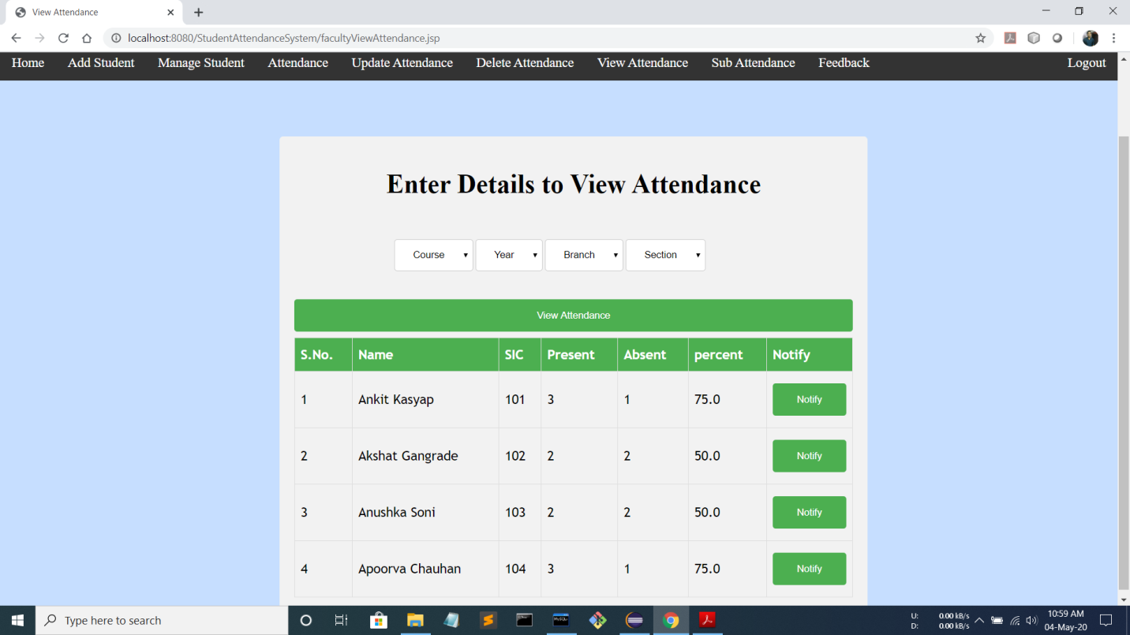

**6.2. Faculty View Subject Attendance Page**

This page is present in the faculty menu. This page facilitates the faculty to view the subjectwise attendance of the students of a particular class and to send attendance notifications to the students in the system.

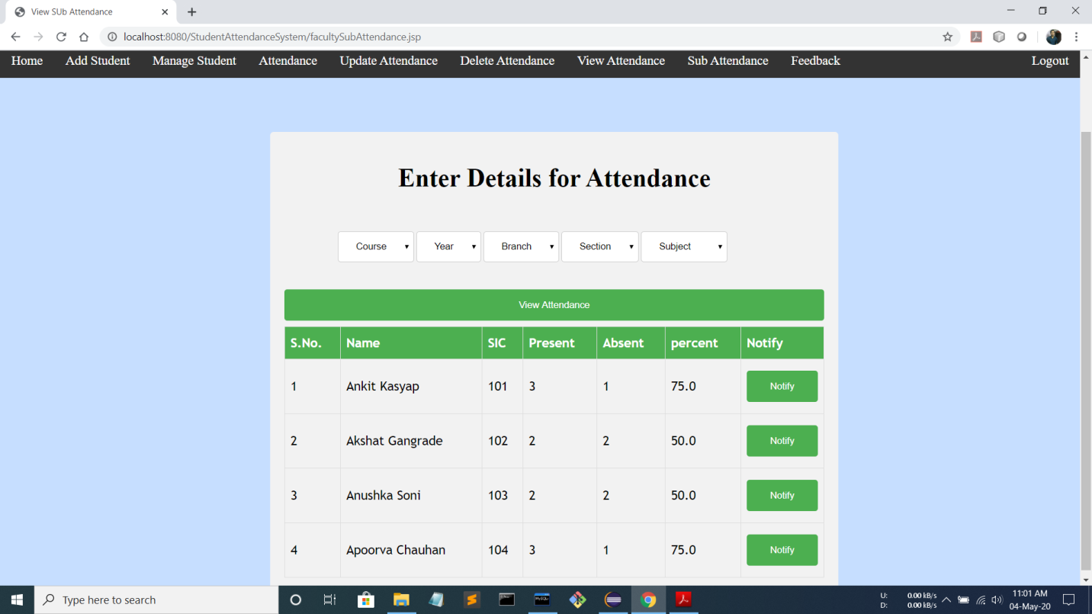

**6.3. Student View Attendance Page**

This page is present in the student menu. This page facilitates the student to view his/her overall attendance in institution, in the system.

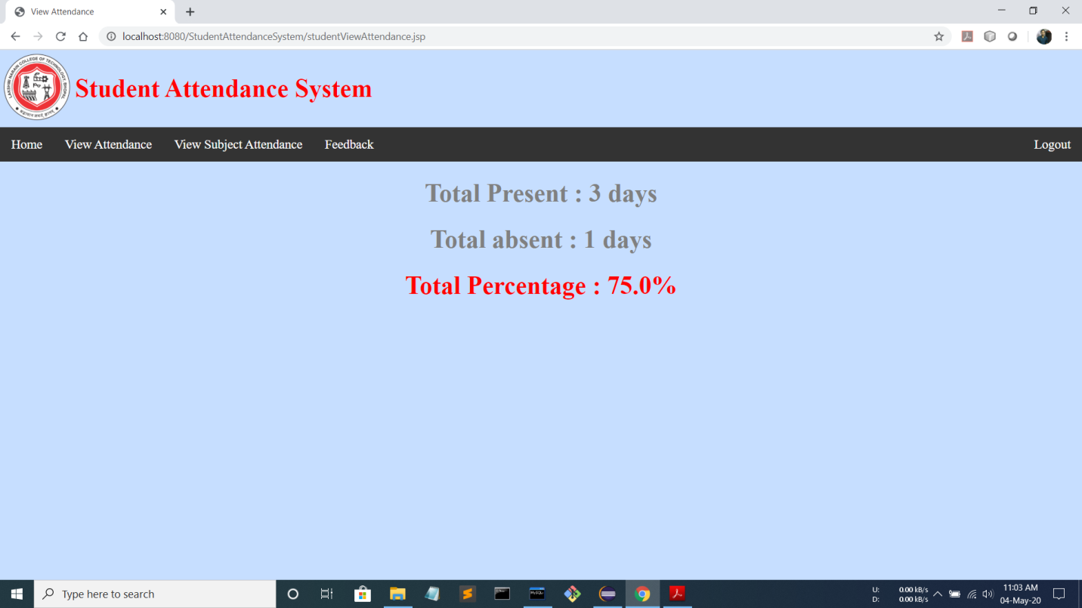

**6.4. Student View Subject Attendance Page**

This page is present in the student menu. This page facilitates the student to view his/her subjectwise attendance in institution, in the system.

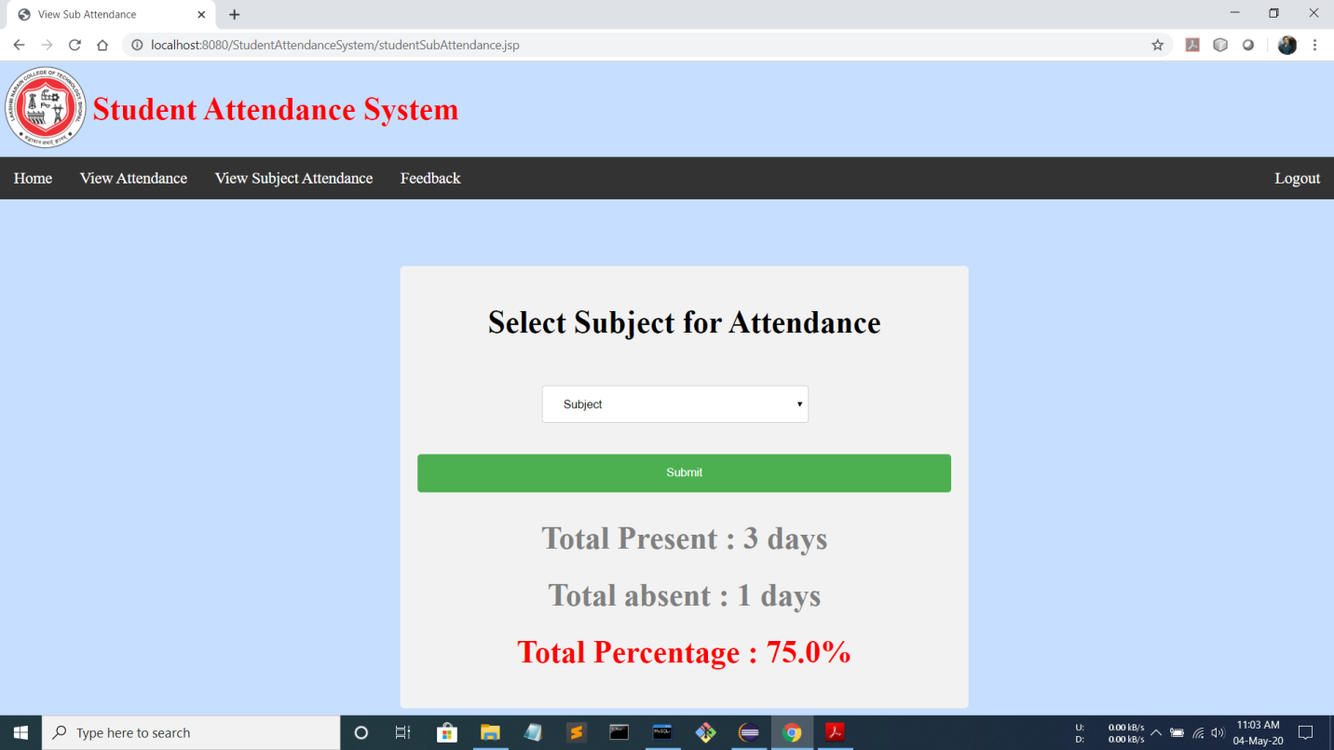

**CHAPTER - 7**

**CONCLUSION**

The Student Attendance System is developed using java fully meets the objectives of the system which it has been developed for. The system has reached a steady state where all bugs have been eliminated. The system is operated at a high level of efficiency and all the faculty and students associated with the system understands its advantage. The system solves the problem. It was intended to solve the requirement specification. It is dynamic, well managed and extremely easy to use. It is secure and safe.

**CHAPTER - 8**

**FUTURE WORK**

The project has a very vast scope in future. The project can be implemented on intranet in future. Project can be updated in near future as and when requirement for the same arises, as it is very flexible in terms of expansion. With the proposed software of database Space Manager ready and fully functional the client is now able to manage and hence run the entire work in a much better, accurate and error free manner.

In future we can also develop a more scalable system, as many more students will enroll in institutions. This software can be used by various institutions therefore this should be robust and must be capable of storing intact information.

With more data, comes more responsibility and more maintenance.

**REFERENCES**

[1] http://www.wikipedia.com

[2] http://www.geeksforgeeks.com

[3] http://www.stackoverflow.com

[4] http://www.sololearn.com

[5] http://www.github.com

[6] http://www.w3schools.com

[7] Richard H.Thayer,”Software Engineering & Project Managements”, Wiley India

[8] Database System Concepts (Sixth Edition, 2011) - Abraham Silberschatz, Henry F. Korth